Codee Online Banking User Manual

Table of Contents:

1. General Description ...........................................................................................3

2. Sign up for an account with Codee Bank ..........................................................3

3. Sign in to Codee Bank Website .........................................................................4

4. Transfer ………..................................................................................................5

5. Check the transaction report ..............................................................................7

6. Manage user’s profile ........................................................................................8

7. Contact, inquire with support staff or sending mail...........................................9

# **1. General Description**

The purpose of this document is to describe the Codee Bank, its functionality and how to work with it. With the Codee Banking System all users can use the following banking services: transfer money to other accounts within the system, check the transaction history and manage user’s profile such as change username or password….

Codee Bank service is available only to those clients that are registered as Codee-Banking users. The user can access only his/ her accounts with a username, password that are chosen by him/her. When using online banking, users can make transactions anytime, anywhere, transfer money without transaction fees, and most importantly, all of the user's personal information is secured.

# **2. Sign up for an account with Codee Bank**

To make an account registration request, the user clicks on the Sign up icon at the top of the web page:



And the following page will appear so you can fill in the information required to register:

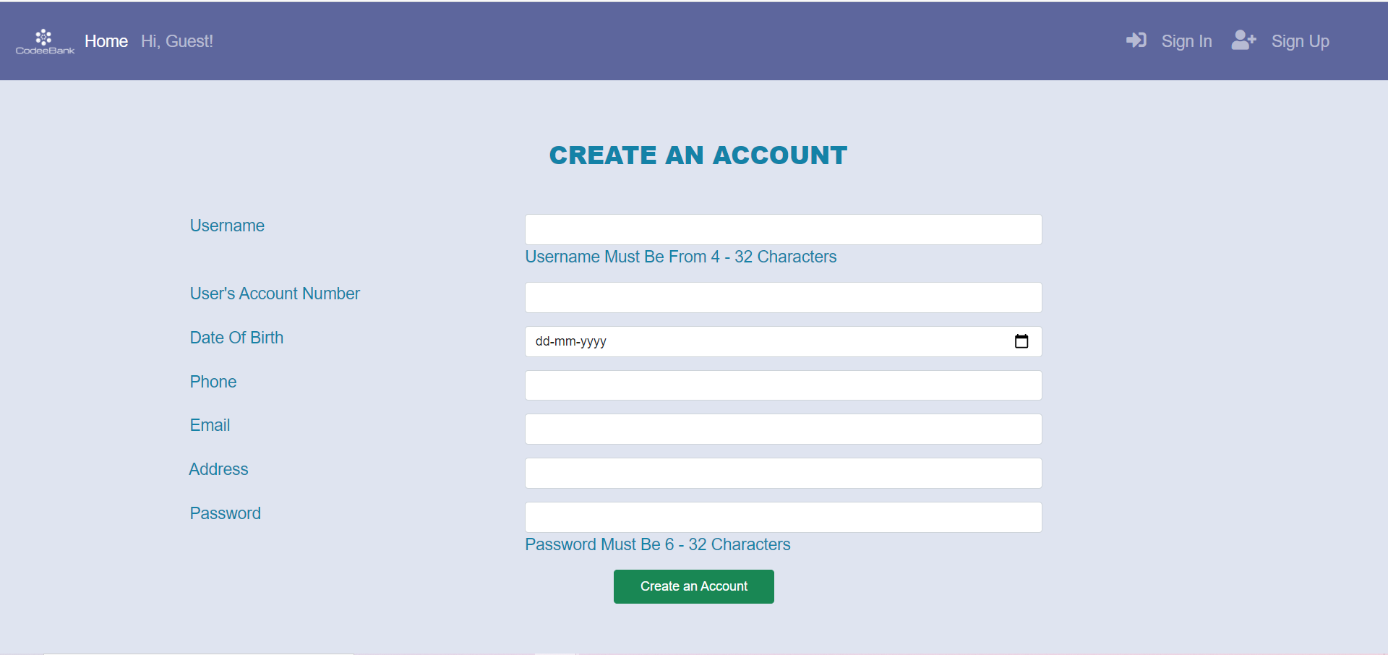

First, user need to enter username with length of bettwen from 4 to 32 characters. Secondary, user enter the bank account number. Then user enter personal information accurately including date of birth, phone number, email address, address. Next, creating a password with at least 6 characters to sign in Codee Bank. After entering all required information, user click “Create an Account” button.

The system will create a new account with your information provided after checking. However, you may also receive the following error messages: “Username already exists”, “Email is registered with another account”, “Password Length Is Not Valid”. To fix, you need to re-enter the correct information, a different username, or another email from you....Please check all your information carefully and remember the username and password you have chosen to be able to log in to the system after creating an account successfully.

# **3. Sign in to Codee Bank**

In order to access Codee Bank you will be required to

1. Enter your username

2. Enter your password

You may either be redirected to the home page if your username and password that you entered is correct or receive an error message: " incorrect username / password" if the information you entered is incorrect. Once you sign in Codee Bank Web you will see the screen below: 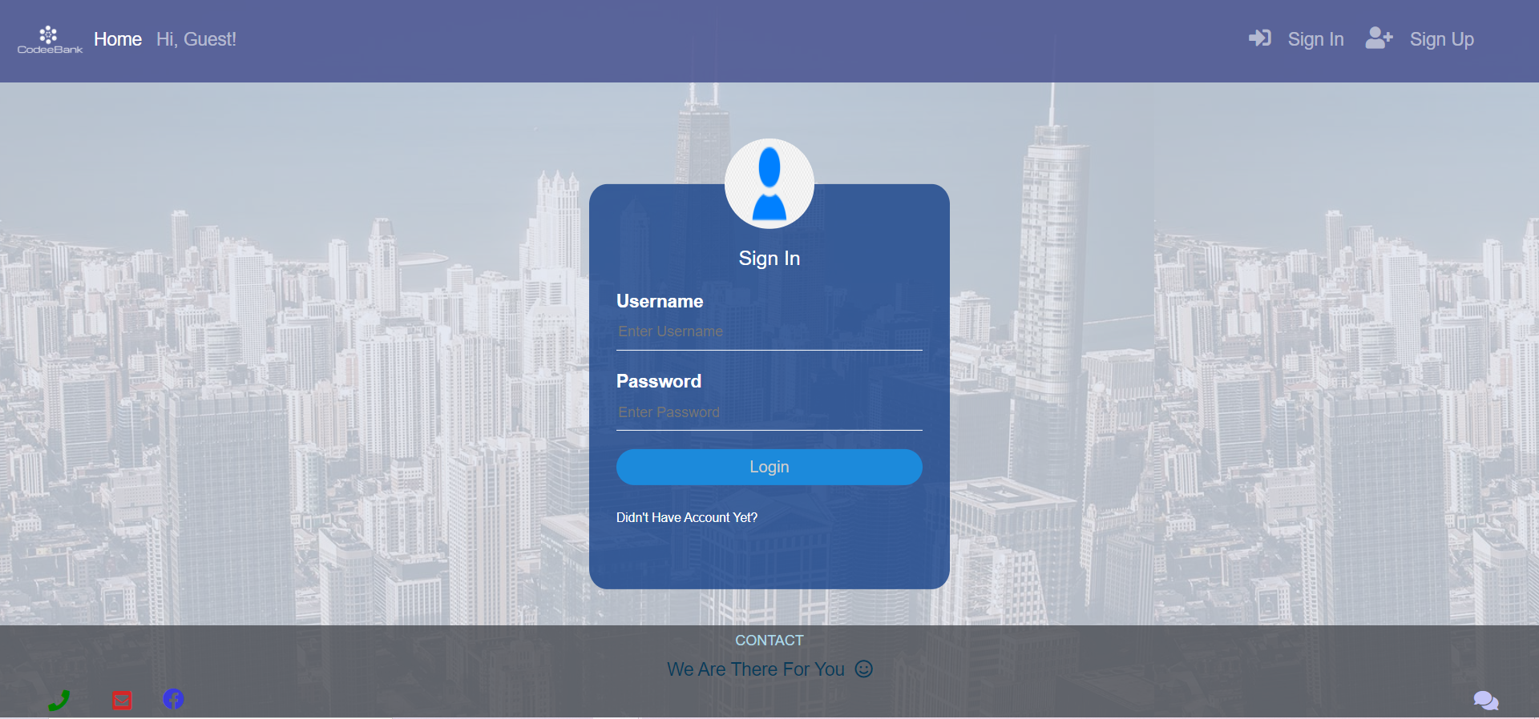

# **4. Transfers**

When you make a transfer within Codee Bank, you click Fund Transfer option on the navigation bar:

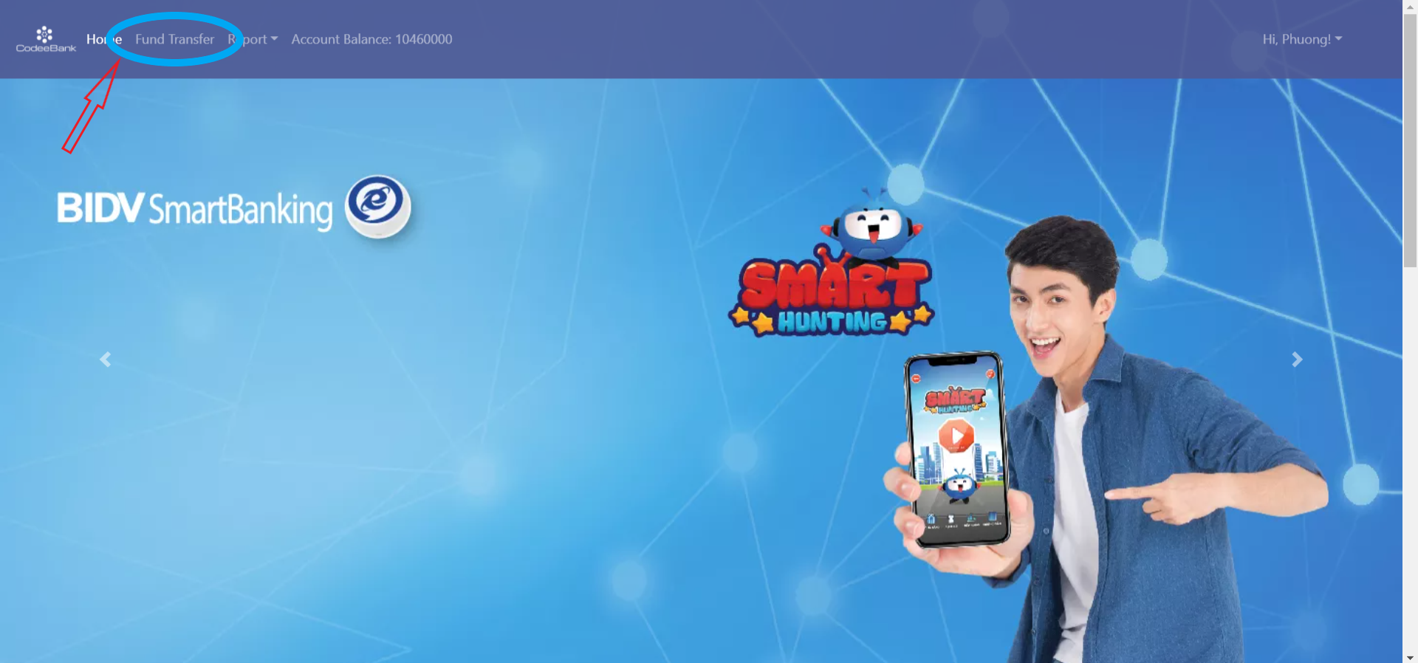

And the screen below wil appear:

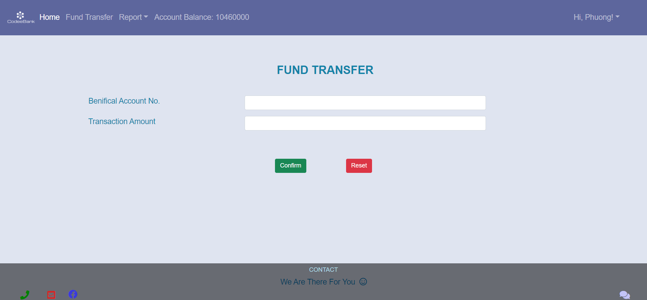

You need to:

1. Enter the exact number of the benefical account number

2. Enter the amount you want to transfer

3. Click Confirm button.

The system will ask: “Are you sure to make this transaction? “, please click Yes to get the transaction done or click Cancel to cancel the transaction. Money transfer transactions in the Codee Banking system are completely free. In case the recipient account number that you entered does not match any of the account numbers registered with the system, this transaction will fail. You also need to check your account balance before making the transaction to avoid insufficient funds.

You can check your balance simply because the balance is displayed on the navigation bar:



The system will need a few seconds to make the transaction. Then you can go to the Report section, choose Fund transfer report to check your transaction, and see your balance has decreased



# **5. Check Fund transfer report**

The system will save your transaction history for you to check at any time. You select the report section in navigation bar, then select Fund transfer report. Your transaction history will be displayed similar to the image below:

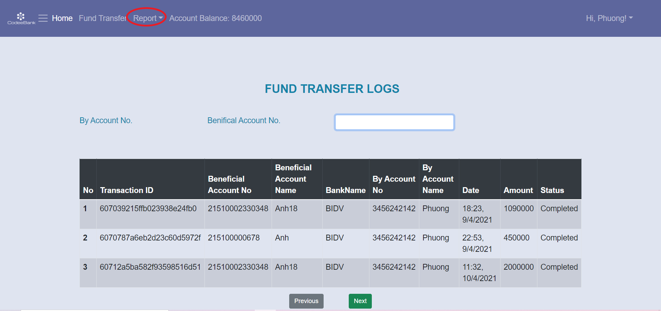

To search for specific transactions, enter the number of beneficia accounts that you want to find and the system will display all transactions related to that account number.

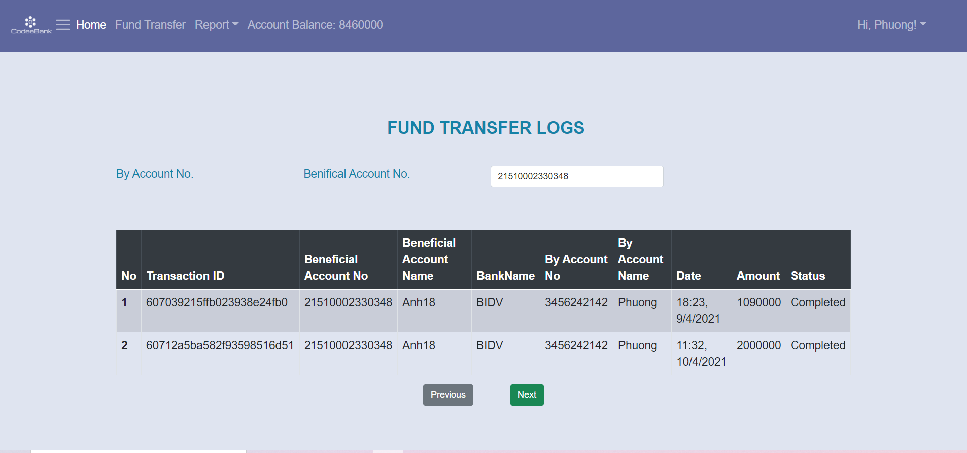

# 6. Manage User’s profile

To view your profile, click Hi! username in the right sight of the navigation bar, then click on my profile option. Your profile will be displayed, and you can edit the information in your profile.

To edit the user name, phone number, email address, you need to delete the old information and enter new information, then enter the password in the confirm password box to verify, then press the Save changes button to save the changes.

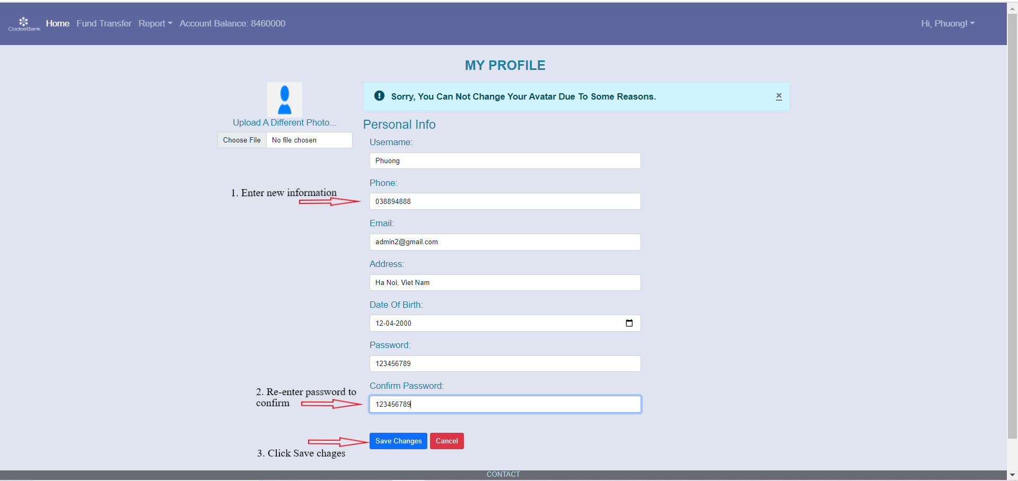

Please wait a few seconds for the system to save these changes, then re-open My profile to see the updated information. If you do not want to change personal information, please click Cancel button.

To change the password, need to:

1. Enter the new password in the password box

2. Re-enter that new password in the Confirm password box.

3. Click Save changes button

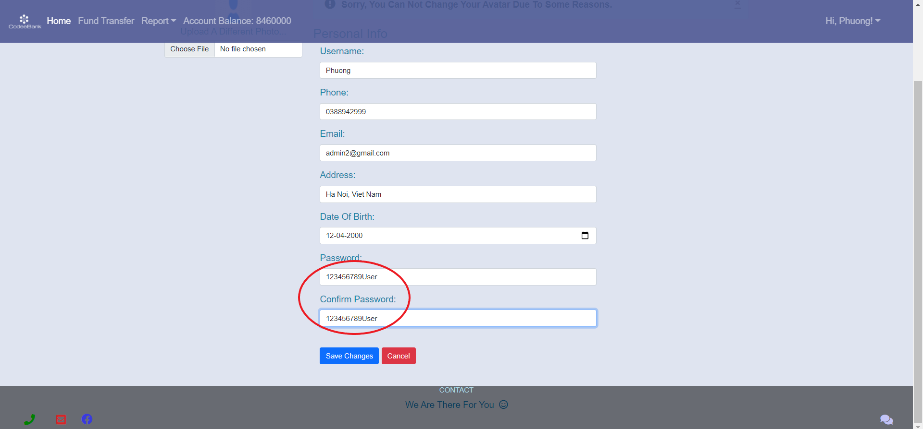

Please make sure the string you entered both times is the same. In case you entered two different character strings, the system will notify you of an error and will not make your request to change your password.